White Paper PoC

Dual-Chamber Prismatic Tesseract Energy Core (PTEC)
with Plasma Relay Switches and Boxed Thrust Vector Mechanics
  - Speculative concept paper for a field-routed propulsion and control architecture
Prepared for: Quellaran / GhostCore concept archive
Version: v2.0 PoC
Date: 2026-03-17

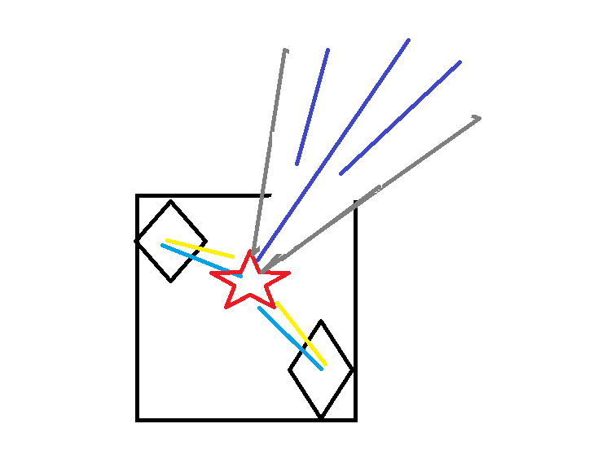
Figure 1. User concept sketch showing the upgraded boxed vector module with outward thrust paths.

Scope note
This document frames the concept as a speculative proof of concept. It separates control-geometry claims (plasma routing, torque bias, vector selection, stabilization) from stronger propulsion claims. A sealed internal field system can steer, phase, and redistribute forces, but measurable net translation still requires momentum exchange through expelled mass, radiated momentum, or coupling to an external field.

Executive Summary
This paper upgrades the original PTEC concept into a dual-chamber internal architecture. The revised module places two rotating PTEC units inside a boxed thrust-vector housing, with plasma relay switches positioned to route energy and ionized working fluid into selectable channels. The geometry shown in the concept sketch suggests a compact vectoring engine: a central core, relay-controlled branch paths, and asymmetric outputs for translation, attitude control, and burst steering.
The strongest engineering interpretation is as a control stack. The inner PTECs generate conditioned field energy; the relay switch network selects the active path; and the boxed vector chamber converts that routing into a directed exhaust or beam path. In that form, the design supports dual-direction movement, torque-state steering, and thrust-vector modulation without relying on mechanical gimbals.

1. Concept Evolution
Earlier PTEC notes described a rotating polyhedral induction core with directional gates, oscillating charge chambers, and geometry-driven field bias. The SCDE concept added counter-polarized wraps for curl, spin, and orientation control. The new upgrade merges those ideas into a single propulsion module: a dual internal PTEC pair, plasma relay switches, and a boxed thrust vector mechanism that channels outputs into multiple angled paths.

2. Proposed Upgraded Architecture

2.1 Core assembly
Layer | Module | Primary control | Purpose
A | Dual internal PTECs | Counter-rotation, phase lock | Generate conditioned electrical and field energy with redundancy and tunable bias.
B | Plasma relay switches | Pulse timing, polarity, aperture state | Route ionized plasma or field discharge into the selected channel with fast switching.
C | Boxed thrust vector chamber | Outlet choice, channel geometry | Convert internal routing into directed vector paths for thrust or steering.
D | SCDE torque wraps | Phase offset, curl ratio | Add rotational bias, attitude control, and spin-state modulation to the selected path.

2.2 Dual-chamber internal PTEC upgrade
The key upgrade is the use of two rotating PTEC units inside one rectangular or boxed containment frame. Rather than a single central core feeding one gate stack, the revised design uses an internal pair. These cores can run in matched rotation for higher throughput, in opposed rotation for stabilization, or in phase-offset mode for differential vector control.
This dual-chamber arrangement provides three practical advantages: higher effective duty cycle, built-in redundancy during relay cycling, and the ability to transfer load between chambers without interrupting the output path. In concept terms, one chamber can seed the plasma channel while the other sustains or redirects it.

2.3 Plasma relay switch manifold
The plasma relay switches act as fast routing nodes between the dual PTEC chambers and the external vector ports. In the user's sketch, the radiating branch lines imply multiple discharge paths from a central hub. This can be interpreted as a multi-port vector manifold. By sequencing the switches, the system can select upward, lateral, or downward branches, creating coarse thrust direction and fine attitude trimming.

3. Operating Logic
Mode | Relay / chamber behavior | Expected effect
Closed-loop conditioning | Both PTECs circulate through internal loads; no external outlet selected. | Power conditioning, field shaping, chamber balancing.
Dual-direction thrust | Relay array selects top or bottom branch while chamber phase reverses. | Up/down directional output or forward/reverse vector bias.
Split-vector steering | Two branches opened at unequal duty cycle from the dual chambers. | Yaw, pitch, or roll correction without moving nozzles.
Torque-state mode | SCDE wraps phase-shift the active channel during discharge. | Spin bias, attitude control, plume curl, stabilization.
Burst propulsion | One chamber primes, one chamber dumps into a selected port with working mass or beam output. | Short impulse event tied to a real reaction mechanism.

4. Thrust Vector Mechanism Interpretation
Placed inside a box, the two rotating PTECs become the energetic heart of a thrust-vector machine. The box matters because it provides a rigid field envelope, controlled spacing between branches, and a predictable mechanical reference frame for instrumentation. Instead of treating the PTEC as a free-floating geometric reactor, this layout treats it as a contained vector module.
In the most credible PoC framing, the boxed chamber does not create propulsion by internal switching alone. It creates propulsion when the relay-selected branch drives one of three external momentum paths: a plasma exhaust stream, an electrothermal nozzle flow, or a directed radiation path. Under that reading, the boxed dual-PTEC module becomes a vector-control engine coupled to a real thrust mechanism.

5. Bench-Scale Proof-of-Concept Path
Phase | Objective | Bench setup | Exit criterion
I | Demonstrate relay-selected plasma path switching | Cold plasma channel with segmented relay electrodes and optical diagnostics | Repeatable selection of two or more branch paths.
II | Demonstrate dual-chamber handoff | Alternating discharge between paired internal sources | Stable output during chamber-to-chamber transfer.
III | Demonstrate torque-state steering | Add SCDE-like wraps around active branch | Measured angular response without a gimbal.
IV | Demonstrate true thrust | Attach nozzle or ion-acceleration stage and thrust stand | Force tracks exhaust momentum above noise and null tests.

6. Measurements
• Electrical: bus voltage, current, switching frequency, phase offset between the two PTECs, and relay timing jitter.
• Plasma: optical plume shape, density proxy, branch-to-branch repeatability, confinement stability, and discharge onset thresholds.
• Mechanical: torsion balance displacement, angular correction rate, support vibration isolation, and cable-force compensation.
• Thermal and EMC: chamber wall temperature, coil heating, stray magnetic coupling into supports, and RF leakage.

7. Risks and False Positives
Risk | Mitigation
Thermal drift misread as thrust | Use null runs, reversed polarity tests, and long settling times.
Electromagnetic coupling into the stand | Isolate supports, route cables symmetrically, and measure background Lorentz effects.
Gas leaks masquerading as vector control | Calibrate all mass-flow paths and repeat under inert control conditions.
Overclaiming internal switching as translation | Keep propulsion claims conditional on verified momentum exchange.

8. Conclusion
The upgraded concept is most coherent when described as a dual-chamber PTEC vector module: two rotating internal PTECs inside a boxed housing, plasma relay switches selecting branch paths, and optional SCDE torque logic shaping plume curl and orientation. That architecture can plausibly support routing, stabilization, and thrust-vector mechanics. Its stronger propulsion claims should remain tied to an explicit external reaction path.
That keeps the white paper ambitious but honest. The geometry still matters. The relay logic still matters. The paired internal cores still matter. But the decisive benchmark is measurable thrust under controlled instrumentation, not the elegance of the field story alone.

Appendix A. Incorporated Concept Threads
• PTEC: rotating polyhedral plasma-induction core, directional gates, standing-wave bias, and internal/external routing logic.
• SCDE: counter-polarized wrap architecture for torque bias, spin-state induction, and rotorless orientation control.
• Plasma throttle path: noble-gas ionization and real exhaust acceleration as the cleanest route from routing concept to measurable propulsion.
• Haloheart-style scaling: multiple PTEC nodes or internal paired chambers for redundancy, load sharing, and harmonic stabilization.

